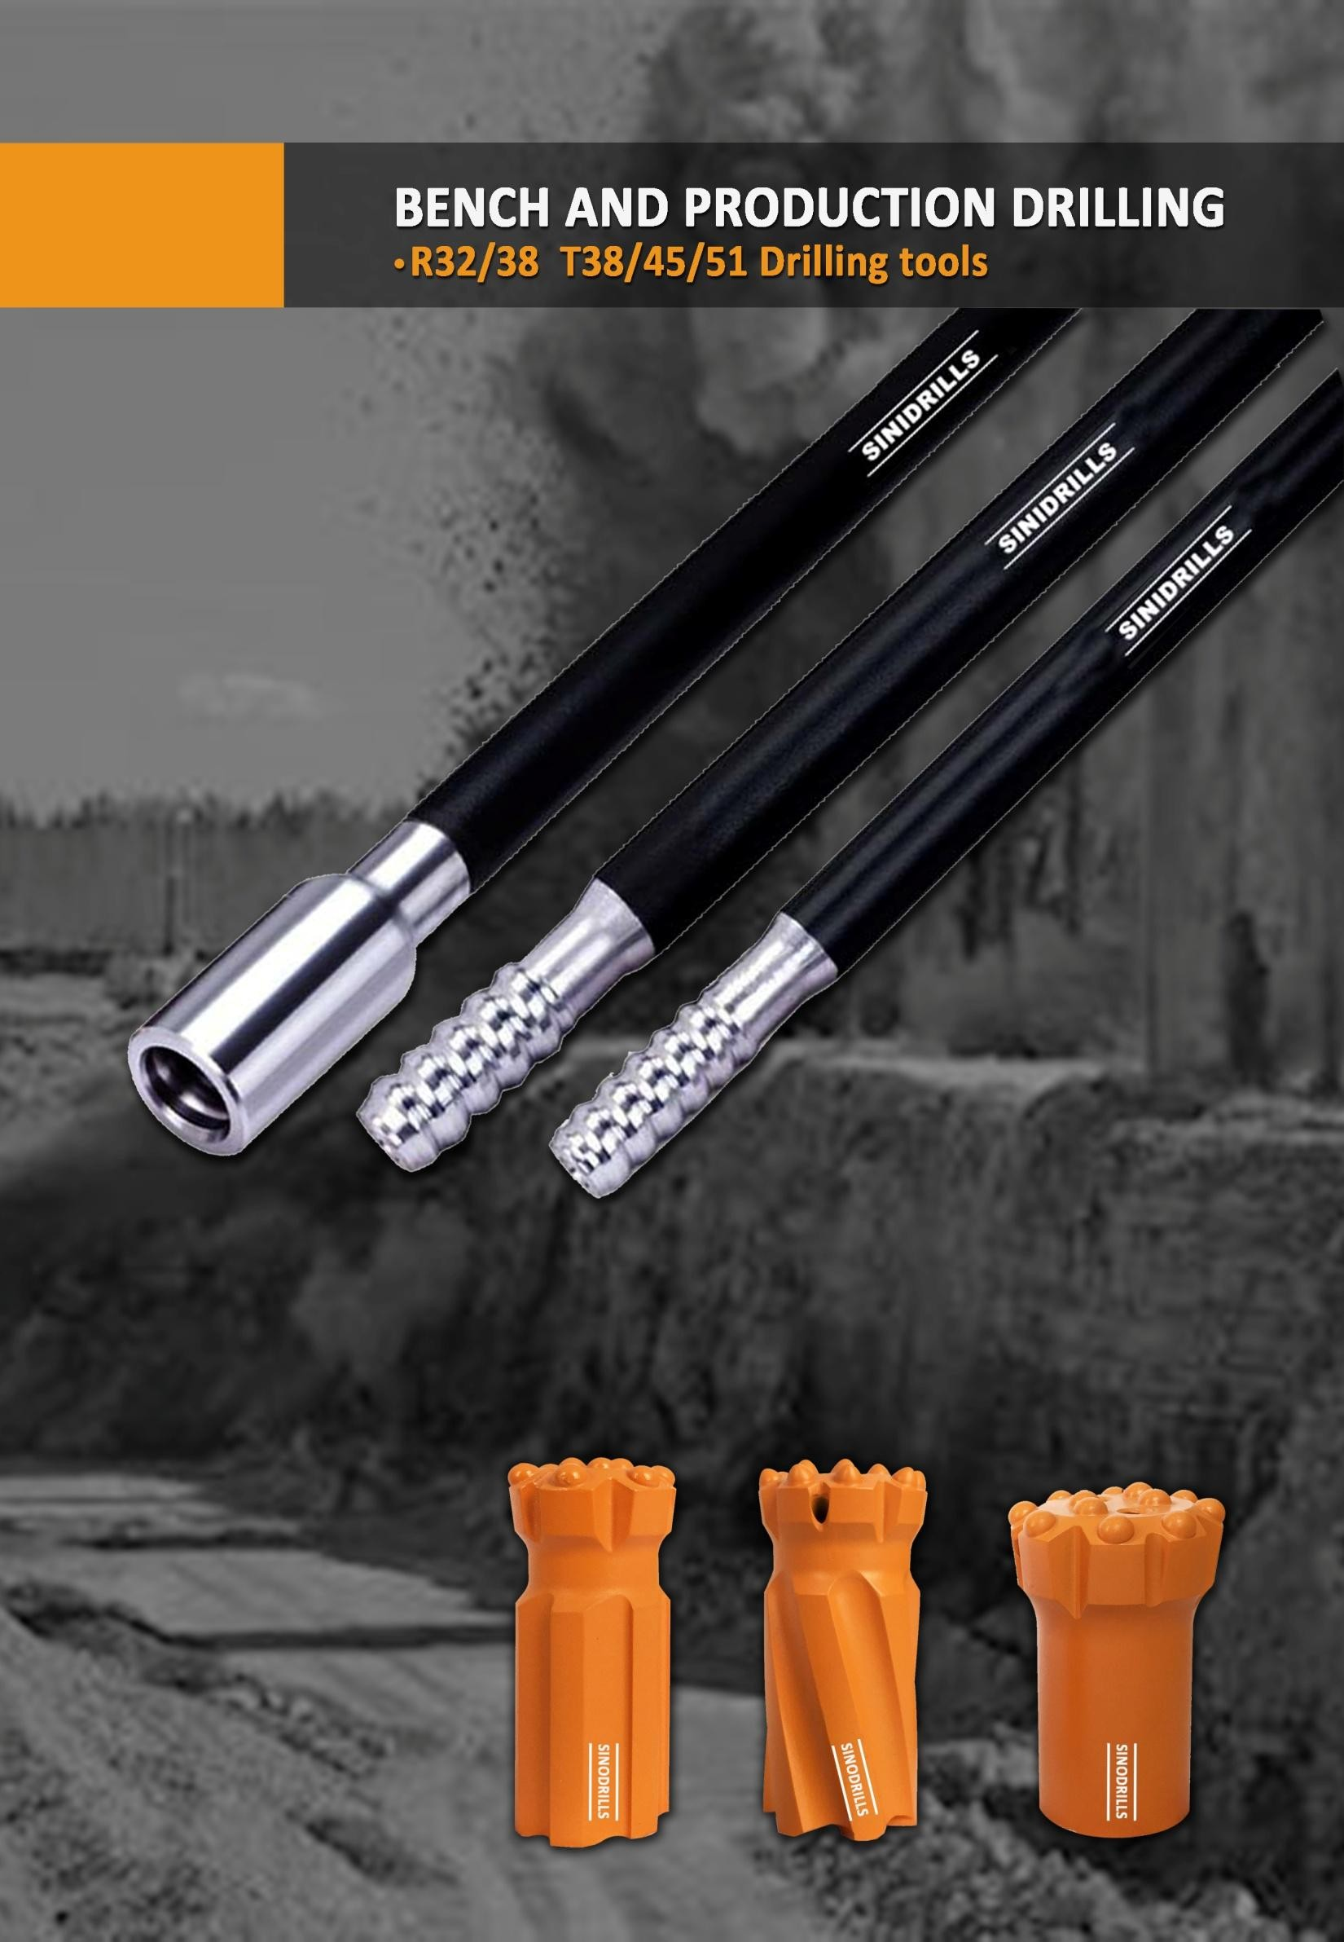

R/T38 (1 1/2’’) Thread bits for retract skirt
 | 64 | 2 1/ 2 | 6X12 | 3X11 | 3 | 0 | 35 | 1.37 | RFF64R/T38B633A
 | 64 | 2 1/ 2 | 6X11 | 3X10 | 3 | 0 | 40 | 1.29 | RFF64R/T38B633S
 | 64 | 2 1/ 2 | 6X11 | 4X10 | 3 | 0 | 40 | 1.43 | RDC64R/T38B643S
 | 64 | 2 1/ 2 | 8X11 | 4X10 | 2 | 0 | 35 | 1.42 | RFF64R/T38B842A
 | 76 | 3 | 8X12 | 5X11 | 4 | 0 | 35 | 3.13 | RDC76R/T38B853  A
 | 76 | 3 | 8X12 | 4X12 | 2 | 0 | 35 | 3.16 | RFF76R/T38B842  A
 | 76 | 3 | 6X12 | 4X11 | 3 | 0 | 40 | 3.07 | RDC75R/T38B642  S
 | 76 | 3 | 6X14 | 3X12/1 X11 | 3 | 0 | 40 | 3.09 | RDC75R/T38B632  S
R/T38 (1 1/2’’) Thread bits for retract skirt
Diameter  mm inch |  | Gauge angle ° | Buttons (  Front | mm)  Gauge | Flushing hole Front Side | Weight Kg | Part number
 | 89 3 1/2 | 8X13 | 4X13 | 2 | 0 40 | 3.24 | RFF89R/T38B842  S
 | 89 3 1/2 | 8X13 | 4X11/1 X11 | 4 | 0 35 | 3.31 | RDC89R/T38B862  A
Extension rod, R38 - Round39 - R38
Length  mm inch |  |  | Diameter  mm inch |  | Weight Kg | Part number
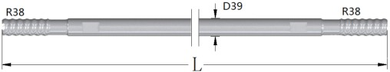 | 1220 | 4′ | 39 | 117/32″ | 9.20 | EXR1220T38R39T38
 | 1525 | 5′ | 39 | 117/32″ | 10.25 | EXR1525T38R39T38
 | 1830 | 6′ | 39 | 117/32″ | 15.3 | EXR1830T38R39T38
 | 3050 | 10 | 39 | 117/32″ | 25.5 | EXR3050R38R39R38
 | 3660 | 12′ | 39 | 117/32″ | 30.6 | EXR3660R38R39R38
 | 4270 | 14′ | 39 | 117/32″ | 35.4 | EXR4270R38R39R38
MF rod, R38 - Round39 - R38
Length  mm inch |  | Dia  mm | meter inch | Weight Kg | Part number
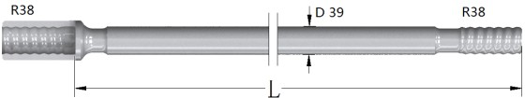 | 3050 10′ | 39 | 117/32″ | 26.5 | MFR3050R38R39R3  8
 | 3660 12′ | 39 | 117/32″ | 31.6 | MFR3660R38R39R3  8
 | 4270 14′ | 39 | 117/32″ | 36.4 | MFR4270R38R39R3  8
Length  mm inch |  | Dia  mm | meter inch | Weight Kg | Part number
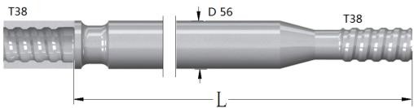 | 1830 6′ | 56 | 2 13/64″ | 25 | GTR1830T38R56T38
 | 3660 12′ | 56 | 2 13/64″ | 51 | GTR3700T38R56T38
Extension rod, T38 - Round39 - T38
Length  mm inch |  |  | Diameter  mm inch |  | Weight Kg | Part number
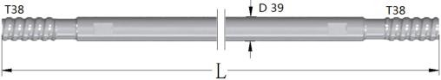 | 1220 | 4′ | 39 | 117/32″ | 9.20 | EXR1220T38R39T38
 | 1525 | 5′ | 39 | 117/32″ | 10.25 | EXR1525T38R39T38
 | 1830 | 6′ | 39 | 117/32″ | 15.3 | EXR1830T38R39T38
 | 3050 | 10 | 39 | 117/32″ | 25.5 | EXR3050T38R39T38
 | 3660 | 12′ | 39 | 117/32″ | 30.6 | EXR3660T38R39T38
 | 4270 | 14′ | 39 | 117/32″ | 35.4 | EXR4270T38R39T38
MF rod, T38 - Round39 - T38
Length  mm inch |  |  | Diameter  mm inch |  | Weight Kg | Part number
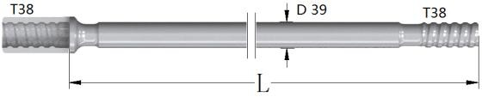 | 1220 | 4′ | 39 | 117/32″ | 9.50 | MFR3050T38R39T38
 | 1525 | 5′ | 39 | 117/32″ | 11.25 | MFR3660T38R39T38
 | 1830 | 6′ | 39 | 117/32″ | 16.3 | MFR4270T38R39T38
 | 3050 | 10 | 39 | 117/32″ | 26.5 | MFR3050T38R39T38
 | 3660 | 12′ | 39 | 117/32″ | 31.6 | MFR3660T38R39T38
 | 4270 | 14′ | 39 | 117/32″ | 36.4 | MFR4270T38R39T38
Guide Tube T38 - Round56 - T38
R/T 38 Coupling sleeve
Thread  A B |  | Diameter  mm inch |  | Length  mm inch |  | Weight Kg | Part number
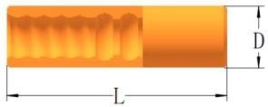 | R32 R38 | 55 | 25/32 | 180 | 71/8 | 1.86 | CPR32R38L180D55
 | R32 T38 | 55 | 25/32 | 180 | 71/8 | 2.10 | CPR32T38L180D55
 | R38 T38 | 55 | 25/32 | 190 | 733/64 | 1.86 | CPR38T38L190D55
 | R38 | 55 | 25/32 | 170 | 657/64 | 1.71 | CPR38L170D55
 | T38 | 55 | 25/32 | 190 | 733/64 | 1.96 | CPT38L190D55

T45 (1 3/4’’) Thread bits for normal skirt
Diameter  mm inch |  |  | Gauge angle ° | Buttons (mm)  Front Gauge |  | Flushing hole Front Side |  | Weight Kg | Part number
 | 76 | 3 | 4X12 | 8X12 | 2 | 0 | 35 | 2.41 | FF76T45B842A
 | 76 | 3 | 4X12 | 8X12 | 2 | 0 | 35 | 2.39 | FF76T45B842A2
 | 76 | 3 | 3X12/1 X11 | 6X13 | 3 | 0 | 35 | 2.33 | DC76T45B643A
 | 76 | 3 | 5X11 | 8X12 | 4 | 0 | 35 | 2.37 | DC76T45B854A
 | 89 | 3 1/2 | 5X12 | 8X14 | 2 | 0 | 35 | 3.67 | FF89T45B852A
 | 89 | 3 1/2 | 5X12 | 8X13 | 4 | 0 | 35 | 3.56 | DC89T45B854A
 | 89 | 3 1/2 | 6X10 | 9X12 | 3 | 0 | 35 | 3.58 | FF89T45B963A
 | 102 | 4 | 6X12 | 8X14 | 2 | 0 | 35 | 5.36 | FF102T45B862A
 | 102 | 4 | 6X12 | 8X14 | 4 | 0 | 35 | 5.26 | DC102T45B864A
 | 102 | 4 | 6X14 | 8X16 | 4 | 0 | 40 | 5.52 | DC102T45B864S
 | 102 | 4 | 8X13 | 9X13 | 3 | 0 | 35 | 5.49 | FF102T45B983A
 | 115 | 4 1/2 | 7X14 | 8X16 | 2 | 0 | 40 | 6.78 | FF115T45B872S
 | 115 | 4 1/2 | 7X13 | 8X14 | 4 | 0 | 35 | 6.62 | DC115T45B874A
 | 115 | 4 1/2 | 8X14 | 9X14 | 3 | 0 | 35 | 6.89 | FF115T45B983A
 | 127 | 5 | 9X14 | 8X16 | 2 | 0 | 40 | 10.13 | FF127T45B892S
 | 127 | 5 | 9X14 | 8X13 | 3 | 0 | 35 | 9.9 | FF127T45B893A
 | 127 | 5 | 9X16 | 8X14 | 3 | 0 | 35 | 10.05 | FF127T45B893H
 | 127 | 5 | 7X14 | 8X14 | 4 | 0 | 35 | 9.71 | DC127T45B874A
Extension rod, T45 - Round46 - T45
Length  mm inch |  | Diameter  mm inch | Weight Kg | Part number
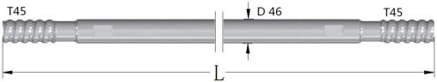 | 3050 10 | 46 1³/₄″ | 35.8 | EXR3050T45R46T45
 | 3660 12′ | 46 1³/₄″ | 43 | EXR3660T45R46T45
 | 4270 14′ | 46 1³/₄″ | 35.4 | EXR4270T45R46T45
MF rod, T45 - Round46 - T45
Length  mm inch |  |  | Diameter  mm inch |  | Weight Kg | Part number
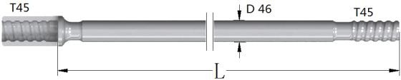 | 1525 | 5′ | 46 | 1³/₄″ | 18.5 | MFR1525T45R46T45
 | 1830 | 6′ | 46 | 1³/₄″ | 22.2 | MFR1830T45R46T45
 | 3050 | 10 | 46 | 1³/₄″ | 36.4 | MFR3050T45R46T45
 | 3660 | 12′ | 46 | 1³/₄″ | 43.7 | MFR3660T45R46T45
 | 4270 | 14′ | 46 | 1³/₄″ | 50.7 | MFR4270T45R46T45
Guide Tube T45 - Round63/76 - T45
Length  mm inch |  | Diameter  mm inch | Weight Kg | Part number
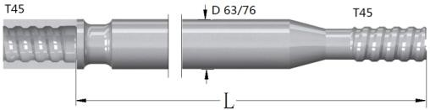 | 1830 6′ | 63 2¹/₂″ | 28 | GTR1830T45R63T45
 | 3660 12′ | 63 2¹/₂″ | 55 | GTR3660T45R63T45
 | 3660 12′ | 76 3″ | 60 | GTR3660T45R76T45
T45 Coupling sleeve
Thread  A B |  | Diameter  mm inch |  | Leng mm | th inch | Weight Kg | Part number
 | T45 | 63 | 215/32 | 210 | 817/64 | 3.12 | CPT45L210D63
 | T45 | 66 | 219/32 | 210 | 817/64 | 3.51 | CPT45L210D66

T51 ( 2’’) Thread bits for normal skirt
Diameter  mm inch |  |  | Gauge angle ° | Buttons (mm)  Front Gauge |  | Flushing hole Front Side |  | Weight Kg | Part number
 | 89 | 3 1/2 | 5X12 | 8X14 | 2 | 0 | 35 | 3.4 | FF89T51B852A
 | 89 | 3 1/2 | 5X13 | 8X13 | 4 | 0 | 35 | 3.29 | DC89T51B854A
 | 89 | 3 1/2 | 6X10 | 9X12 | 3 | 0 | 35 | 3.35 | FF89T51B963A
 | 89 | 3 1/2 | 5X11 | 8X12 | 4 | 0 | 35 | 3.15 | FF89T51B854A
 | 102 | 4 | 6X12 | 8X14 | 2 | 0 | 35 | 5.31 | FF102T51B862A
 | 102 | 4 | 6X12 | 8X14 | 4 | 0 | 35 | 5.21 | DC102T51B864A
 | 102 | 4 | 6X14 | 8X16 | 4 | 0 | 40 | 5.50 | DC102T51B864S
 | 102 | 4 | 8X13 | 9X13 | 3 | 0 | 35 | 5.49 | FF102T51B983A
 | 115 | 4 1/2 | 7X14 | 8X16 | 2 | 0 | 40 | 6.24 | FF115T51B872S
 | 115 | 4 1/2 | 7X13 | 8X14 | 4 | 0 | 35 | 6.13 | DC115T51B874A
 | 115 | 4 1/2 | 8X14 | 9X14 | 3 | 0 | 35 | 6.45 | FF115T51B983A
 | 127 | 5 | 9X14 | 8X16 | 2 | 0 | 40 | 10.30 | FF127T51B892S
 | 127 | 5 | 8X13 | 9X14 | 3 | 0 | 35 | 10.07 | FF127T51B983A
 | 127 | 5 | 8X14 | 9X16 | 3 | 0 | 35 | 10.24 | FF127T51B983H
 | 127 | 5 | 7X14 | 8X14 | 4 | 0 | 35 | 9.88 | DC127T51B874A
 | 140 | 5 1/2 | 8X14 | 10X16 | 2 | 0 | 35 | 10.30 | FF140T51B1082A
 | 140 | 5 1/2 | 8X16 | 8X16 | 2 | 0 | 40 | 11.75 | FF140T51B882H
 | 140 | 5 1/2 | 4X14-  4X12 | 8X16 | 4 | 0 | 35 | 11.31 | DC140T51B884A
 | 140 | 5 1/2 | 9X13 | 9X14 | 3 | 0 | 35 | 11.66 | FF140T51B993A
T51 ( 2’’) Thread bits for normal skirt
Diameter  mm inch |  | Gauge angle ° | Buttons (  Front | mm)  Gauge | Flushing hole Front Side | Weight Kg | Part number
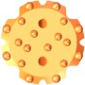 | 152 6 | 10X14 | 10X16 | 3 | 0 35 | 13.74 | FF152T51B1082A
 | 152 6 | 10X14 | 8X16 | 2 | 0 35 | 14.37 | FF152T51B8102A
 | 152 6 | 9X16 | 9X16 | 3 | 0 35 | 14.24 | FF152T51B993A
T51 ( 2’’) Thread bits for retract skirt
Diameter  mm inch |  |  | Gauge angle ° | Buttons (mm)  Front Gauge |  | Flushing hole Front Side |  | Weight Kg | Part number
 | 89 | 3 1/2 | 5X12 | 8X14 | 2 | 0 | 35 | 4.68 | R89T51B852A
 | 89 | 3 1/2 | 5X13 | 8X13 | 4 | 0 | 35 | 4.60 | RC89T51B854A
 | 89 | 3 1/2 | 6X10 | 9X12 | 3 | 0 | 35 | 4.52 | RF89T51B963A
 | 102 | 4 | 6X12 | 8X14 | 2 | 0 | 35 | 7.21 | RFF102T51B862A
 | 102 | 4 | 6X12 | 8X14 | 4 | 0 | 35 | 7.21 | RDC102T51B864A
 | 102 | 4 | 6X14 | 8X16 | 4 | 0 | 40 | 7.40 | RDC102T51B864S
 | 102 | 4 | 8X13 | 9X13 | 3 | 0 | 35 | 7.45 | RFF102T51B983A
 | 115 | 4 1/2 | 7X14 | 8X16 | 2 | 0 | 40 | 9.44 | RFF115T51B872S
 | 115 | 4 1/2 | 7X13 | 8X14 | 4 | 0 | 35 | 9.19 | RDC115T51B874A
 | 115 | 4 1/2 | 8X14 | 9X14 | 3 | 0 | 35 | 9.25 | RFF115T51B983A
 | 127 | 5 | 9X14 | 8X16 | 2 | 0 | 40 | 12.86 | RFF127T51B892S
 | 127 | 5 | 8X13 | 9X14 | 3 | 0 | 35 | 12.35 | RFF127T51B983A
 | 127 | 5 | 8X14 | 9X16 | 3 | 0 | 35 | 12.25 | RFF127T51B983H
 | 127 | 5 | 7X14 | 8X14 | 4 | 0 | 35 | 12.52 | RDC127T51B874A
Extension rod, T51 - Round52 - T51
Length  mm inch |  | Diameter  mm inch | Weight Kg | Part number
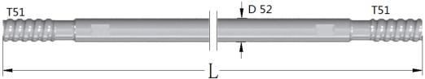 | 3660 12′ | 52 2″ | 54.2 | EXR3660T51R52T51
 | 4270 14′ | 52 2″ | 63.5 | EXR4270T51R52T51
MF rod, T51 - Round52 - T51
Length  mm inch |  |  | Diameter  mm inch |  | Weight Kg | Part number
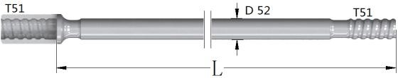 | 1525 | 5′ | 52 | 2″ | 17.85 | MFR3660T51R52T51
 | 1830 | 6′ | 52 | 2″ | 28.10 | MFR4270T51R52T51
 | 3660 | 12′ | 52 | 2″ | 55.7 | MFR3660T51R52T51
 | 4270 | 14′ | 52 | 2″ | 64.8 | MFR4270T51R52T51
Guide Tube T51 - Round76/87- T51
Length  mm inch |  | Diameter  mm inch | Weight Kg | Part number
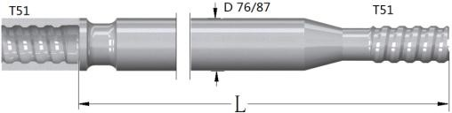 | 1830 6′ | 76 3″ | 35 | GTR1830T51R76T51
 | 3660 12′ | 76 3″ | 79.5 | GTR3660T51R76T51
 | 3660 12′ | 87 3¹/₂″ | 88 | GTR3660T51R87T51
T51 Coupling sleeve
Thread  A B |  | Diameter  mm inch | Length  mm inch | Weight Kg | Part number
 | T51 | 72 27/8 | 235 9¹/₄ | 5.22 | CPT51L235D72
 | T51 | 76 3 | 235 9¹/₄ | 5.75 | CPT51L235D76

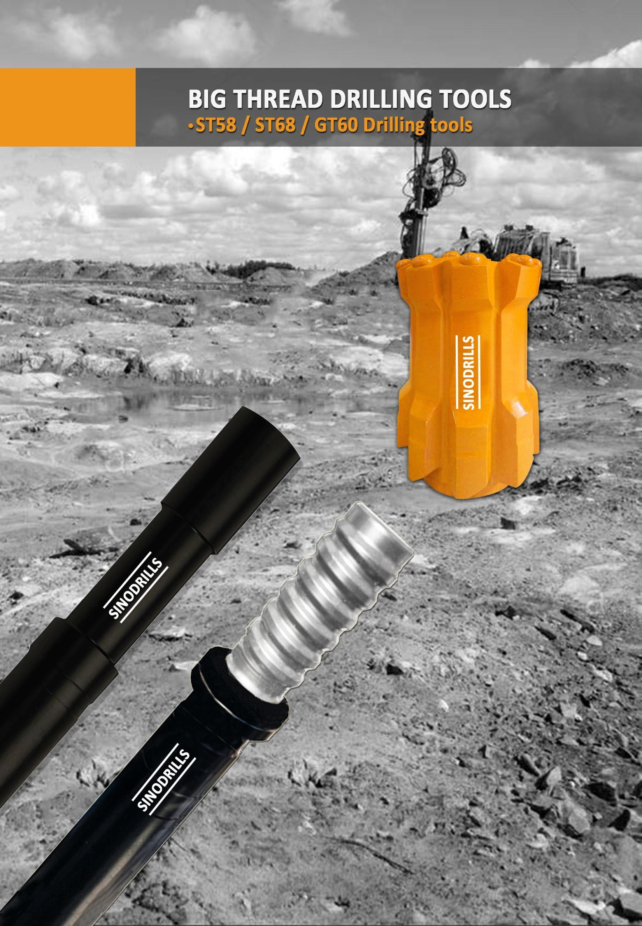

GT60 ( 2 3/8’’) Thread bits for retract
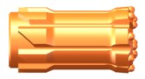
Diameter  mm inch |  |  | Gauge angle ° | Buttons (mm)  Front Gauge |  | Flushing hole Front Side |  | Weight Kg | Part number
 | 102 | 4 | 6X12 | 8X14 | 2 | 0 | 35 | 8.7 | RFF102G60B862A
 | 102 | 4 | 6X12 | 8X14 | 4 | 0 | 35 | 8.53 | RDC102G60B864A
 | 102 | 4 | 6X14 | 8X16 | 4 | 0 | 40 | 8.75 | RDC102G60B864S
 | 102 | 4 | 8X13 | 9X13 | 3 | 0 | 35 | 8.7 | RFF102G60B983A
 | 115 | 4 1/2 | 7X14 | 8X16 | 2 | 0 | 40 | 9.44 | RFF115G60B872S
 | 115 | 4 1/2 | 7X13 | 8X14 | 4 | 0 | 35 | 9.19 | RDC115G60B874A
 | 127 | 5 | 9X14 | 8X16 | 2 | 0 | 40 | 16.03 | RFF127G60B982S
 | 127 | 5 | 8X13 | 9X14 | 3 | 0 | 35 | 15.77 | RFF12760B893A
 | 127 | 5 | 8X14 | 9X16 | 3 | 0 | 35 | 15.56 | RFF127TG60B893H
 | 127 | 5 | 7X14 | 8X14 | 4 | 0 | 40 | 15.95 | RDC127G60B874S
 | 140 | 5 1/2 | 8X14 | 10X16 | 3 | 0 | 35 | 19.72 | RFF140G60B1082A
 | 140 | 5 1/2 | 8X16 | 8X16 | 2 | 0 | 40 | 20.56 | RFF140G60B882H
 | 140 | 5 1/2 | 4X14-  4X12 | 8X14 | 4 | 0 | 35 | 19.63 | RDC140G60B884A
 | 140 | 5 1/2 | 9X13 | 9X14 | 3 | 0 | 35 | 20.21 | RFF140G60B993A
 | 152 | 6 | 10X14 | 10X16 | 3 | 0 | 35 | 17.2 | RFF152G60B10102A
 | 152 | 6 | 10X14 | 8X16 | 2 | 0 | 35 | 15.95 | RFF152G60B8102A
 | 152 | 6 | 9X16 | 9X16 | 3 | 0 | 35 | 15.84 | RFF152T51B993A

MF rod, GT60 - Round60 - GT60
Length  mm inch |  | Diameter  mm inch | Weight Kg | Part number
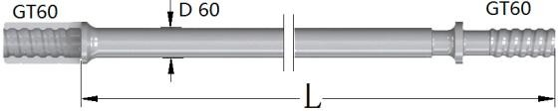 | 4265 14′ | 60 2³/₈″ | 87 | MFR4265GT60R60GT6  0

